Biology 1114 – General Biology Syllabus Cover Sheet
Spring 2025 ● CRN 21446 ● MW 12:00 to 1:50 PM


Professor: Dr. James (Jim) Enderby Bidlack
Office: HOH 301B Lab: HOH 255
Office Phone: (405) 974-5927
Office Hours: TR 10:00-11:50 AM, F 3:00-3:50 PM
Website: https://bidlack.net/ or https://bidlack.org/
UCO email address: jbidlack@uco.edu

BIO 1114 - General Biology
This is an introduction to the life sciences as a course to fulfill the general education requirement for non-biology majors. The topics include an introduction to the fundamental principles of biology, the scientific method, cell structure and organization, biological molecules and metabolism, the levels of biological organization and systematics, plant and animal systems, Mendelian genetics, heredity, evolution, and ecology. This course does not have an accompanying laboratory session and does not count towards a B.S. degree in Biology.

Note on University Life Sciences Lab: To take BIO 1211 (University Life Sciences Laboratory), students are required to have taken, or are concurrently enrolled, in the BIO 1114 (General Biology Lecture) course.

BIO 1114 - Objectives of the Course
- To promote science literacy, critical thinking, and the role of science in society through an understanding of the fundamental principles of biology.
- To encourage the student to use the scientific method for problem solving and relate science to everyday life.
- To give students an appreciation for the diversity of life.
- To provide basic knowledge about the structure and function of living organisms.
- To increase awareness of the impacts of human activities on the biosphere.

BIO 1114 - Student Learning Outcomes (SLOs)
- Identify the properties of life.
- Apply the scientific methodology to the study of life and natural phenomena.
- Explain the biochemical processes of life.
- Identify evolutionary processes and supporting evidence.
- Categorize the hierarchy of life.
- Apply biological concepts to societal issues.

BIO 1114 - Transformative Learning (Central Six)
- Discipline Knowledge: General Biology provides you with an introduction to life around and within you.
- Leadership: General Biology encourages you to work as guided by the core values of character, civility, and community in a cooperative manner in class and small group settings to learn about stewardship of natural resources and yourself.
- Research, Scholarly and Creative Activities: General Biology contributes to this theme by helping you learn what scientists do and the scientific method.
- Service Learning and Civic Engagement: In General Biology, you learn biological concepts related to the world and you will be encouraged to collaborate with student organizations and events to lend a hand in your respective community to help make this a better and sustainable world.
- Global and Cultural Competencies: During lectures and outside assignments you will gain insight into the diversity of life in the world around you as well as some of the major conservation crises facing all of us. This prepares you to communicate effectively in a complex world, to function in diverse environments, to adapt to a continuously changing global society, and to be a lifelong learner who is aware of the world.
- Health and Wellness: With vitality and meaning. General Biology introduces you to well-being by discussing diseases that society face.
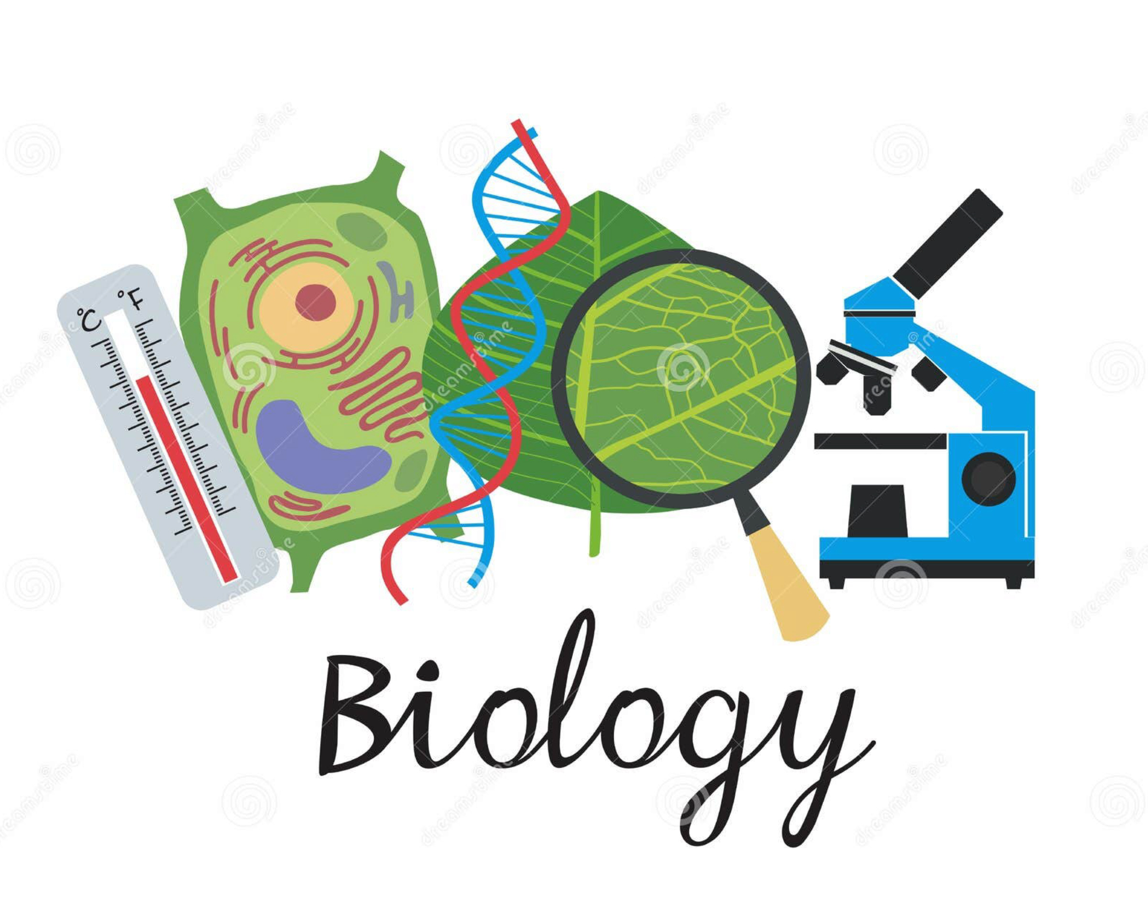

BIOLOGY 1114 Spring 2025
CRN 21446 Tentative Syllabus

GENERAL BIOLOGY Dr. Jim Bidlack
CRN 21446: MW 12:00-1:50 PM 301B HOH (Howell Hall-Office)
154 HOH (Howell Hall) 255 HOH (Lab Annex Building-LAB)
https://bidlack.net/ or https://bidlack.org/ Phone: (405) 974-5927
https://www3.uco.edu/centraldirectory/profiles/2120 E-mail: jbidlack@uco.edu
Office Hours: TR 10:00-11:50 AM
F 3:00-3:50 PM

GENERAL BIOLOGY: This is an introduction to the life sciences as a course to fulfill the general education requirement for non-biology majors. The topics include an introduction to the fundamental principles of biology, the scientific method, cell structure and organization, biological molecules and metabolism, the levels of biological organization and systematics, plant and animal systems, Mendelian genetics, heredity, evolution and ecology. This course does not have an accompanying laboratory session and does not count towards a B.S. degree in Biology. A student will not receive credit for having taken both BIO 1114 and BIO 1214.

Date Lecture topic Lecture Number
January
13 M Introduction, unity and diversity of life Lectures 1 and 2
15 W Scientific method, chemistry Lectures 3 and 4

20 M Martin Luther King Jr. Holiday
22 W Chemistry, biological molecules Lectures 4, 6, and 7

27 M Biological molecules Lectures 6 and 7
29 W Cell structure, enzymes Lectures 5 and 8

February
3 M Enzymes, photosynthesis Lectures 8 and 9
5 W Photosynthesis, respiration Lectures 9, 10, and 11

10 M Additional exam material, molecular biology Lecture 12
12 W EXAM I, molecular biology Lecture 12

17 M Protein synthesis, genetic control Lectures 13 and 14
19 W Genetic engineering Lecture 15

24 M Mitosis and meiosis Lectures 16 and 17
26 W Mendelian and population genetics Lecture 18

March
3 M Additional exam material, evolution Lecture 19
5 W EXAM II, evolution Lecture 19

Date Lecture topic Lecture Number
March (continued)
10 M Viruses, monerans, protistans, fungi, plants Lectures 20 and 21
12 W Plant morphology and anatomy Lectures 22 and 23
Creative Project

17 M Spring Break
19 W Spring Break

24 M Plant nutrition and transport Lecture 24
26 W Additional exam material, animal diversity Lecture 25

31 M EXAM III, animal diversity Lecture 25

April
2 W Human evolution, tissues, systems Lectures 26 and 27
Writing Assignment
7 M Nervous and endocrine systems Lectures 28 and 29
9 W Circulation, immunity, respiration Lectures 31 and 32

14 M Respiration, digestion, reproduction Lectures 32, 33, and 34
16 W Human reproduction and development Lecture 34

21 M EXAM IV, population ecology Lecture 35
23 W Community interactions, ecosystems Lectures 36 and 37

28 M Biosphere, human impact Lecture 38
30 W Animal and social behavior Lecture 39

May
5-9 FINAL EXAMINATIONS

The Final Exam is scheduled for Wednesday, 11 May 2025 at 11:00 AM to 12:50 PM.

The Central Six
At the University of Central Oklahoma, we are guided by the mission of helping students learn by providing transformative experiences so that they may become productive, creative, ethical and engaged citizens and leaders contributing to the intellectual, cultural, economic and social advancement of the communities they serve. Transformative learning is a holistic process that places students at the center of their own active and reflective learning experiences. A student's major field is central to the learning experience and is a vital part of the "Central Six." All students will be transformed with Discipline Knowledge, Leadership, Problem Solving (Research, Scholarly and Creative Activities), Service Learning and Civic Engagement, Global and Cultural Competencies, and Health and Wellness.

BIOLOGY 1114 - GENERAL BIOLOGY
Spring 2025 • CRN 21446 • Dr. Jim Bidlack
Office Phone: (405) 974-5927 • UCO Weather Line: (405) 974-2002
E-Mail: jbidlack@uco.edu
Internet: https://bidlack.net/or https://bidlack.org/ or https://www3.uco.edu/centraldirectory/profiles/2120
Office: TR 10:00-11:50 AM and F 3:00-3:50 PM or by appointment, 301B Howell Hall
Avoid Scheduling Office Visits Just Before Class

Textbook: Houtman, A., Scudellari, M., and Malone, E. 2024. Biology Now (with Physiology). 4th Edition.
W. W. Norton & Company, Inc. New York, NY, USA.

Attendance: Students are expected to attend, learn, and take notes in all classes. At least three hours of study time should be devoted to each hour of class before and/or after lecture.

Grading: An approximate breakdown of points for the course is as follows:

4 lecture exams @ 100 points each 400
1 final exam @ 100 points 100
Creative project @ 50 points 50
Writing assignment @ 50 points 50
_________________________________________________________________
TOTAL POSSIBLE POINTS 600

Grading scale Grade Points needed

90 - 100% of total possible points A 540
80 - 89% of total possible points B 480
70 - 79% of total possible points C 420
60 - 69% of total possible points D 360
Below 60% of total possible points F -

Exam material: At least half of the exam material will come directly from lecture. Other questions may come from additional topics covered in class or assignments. For best performance, review the lecture outlines before class and review lecture notes after each class. Study your notes carefully and review the major topics provided in class. Sample exams are available at https://bidlack,net/ or https://bidlack.org/ and on reserve in the Max Chambers Library. These sample exams should be used as a study guide and not as the sole source for exam preparation.

Exams: All exams will consist mostly of multiple-choice, matching, true-false, short answer, and short essay questions, unless specified otherwise. All exams count in determining the final grade. Make-up exams will be given only in extenuating circumstances and will usually consist of long essay questions. WRITTEN DOCUMENTATION FROM YOUR PHYSICIAN OR UNIVERSITY OFFICIAL MUST BE PROVIDED TO BE CONSIDERED FOR A MAKE-UP EXAM.

Cheating: All work should be that of the student alone. No communication, notes, or wireless devices are permitted during any exam. If the instructor determines that a student has cheated on an exam or any assignment, the student will receive no credit for that exam or assignment and the student’s name will be reported to the proper authorities.

For additional student information that accompanies this syllabus, go to the link on the Internet at:

https://www.uco.edu/academic-affairs/files/aa-forms/StudentInfoSheet.pdf

